Grave Mind – Side Scroller

Custom Project Final Report

Summer 2018

Miguel Andrade

Table of Contents

**Introduction 2**

**Hardware 2**

Parts List **2**

Pinout **3**

**Software 3**

**Complexities 8**

Completed Complexities: **8**

Incomplete complexities: **8**

**Youtube Link 8**

**Known Bugs and Shortcomings 8**

**What did you learn 8**

**International Component 9**

# Introduction

Grave Mind is an automatic scroller that allows you to choose from 4 different avatars. The game tests your ability to last for approximately over 1000 seconds. If you can reach this milestone, you win the game. The game is able to reset and once it does you can rechoose your avatar and play the game once more.

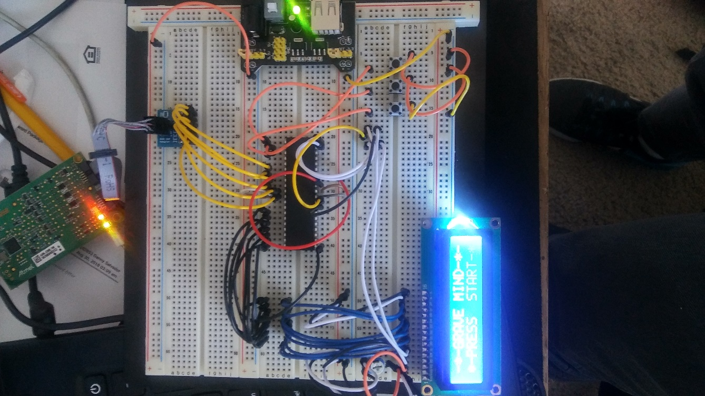

# Hardware

## Parts List

The hardware that was used in this design is listed below. The equipment that was not taught in this course has been bolded.

* ATMega1284p microcontroller
* 16x2 LCD Display
* EEPROM
* Buttons
* Potentiometer

## **Pinout**

16x 2 LCD

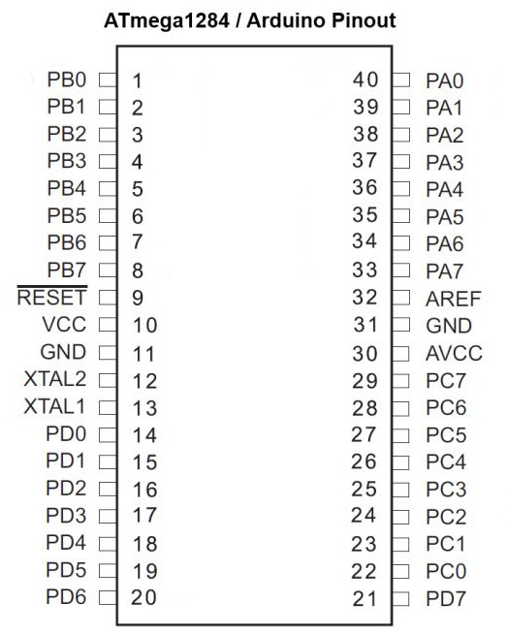

BUTTONS controllers

LCD AVR PORTS

16x 2 LCD

# Software

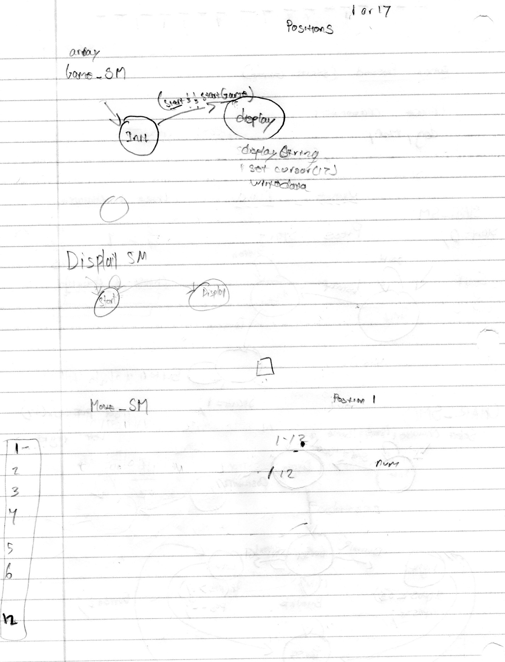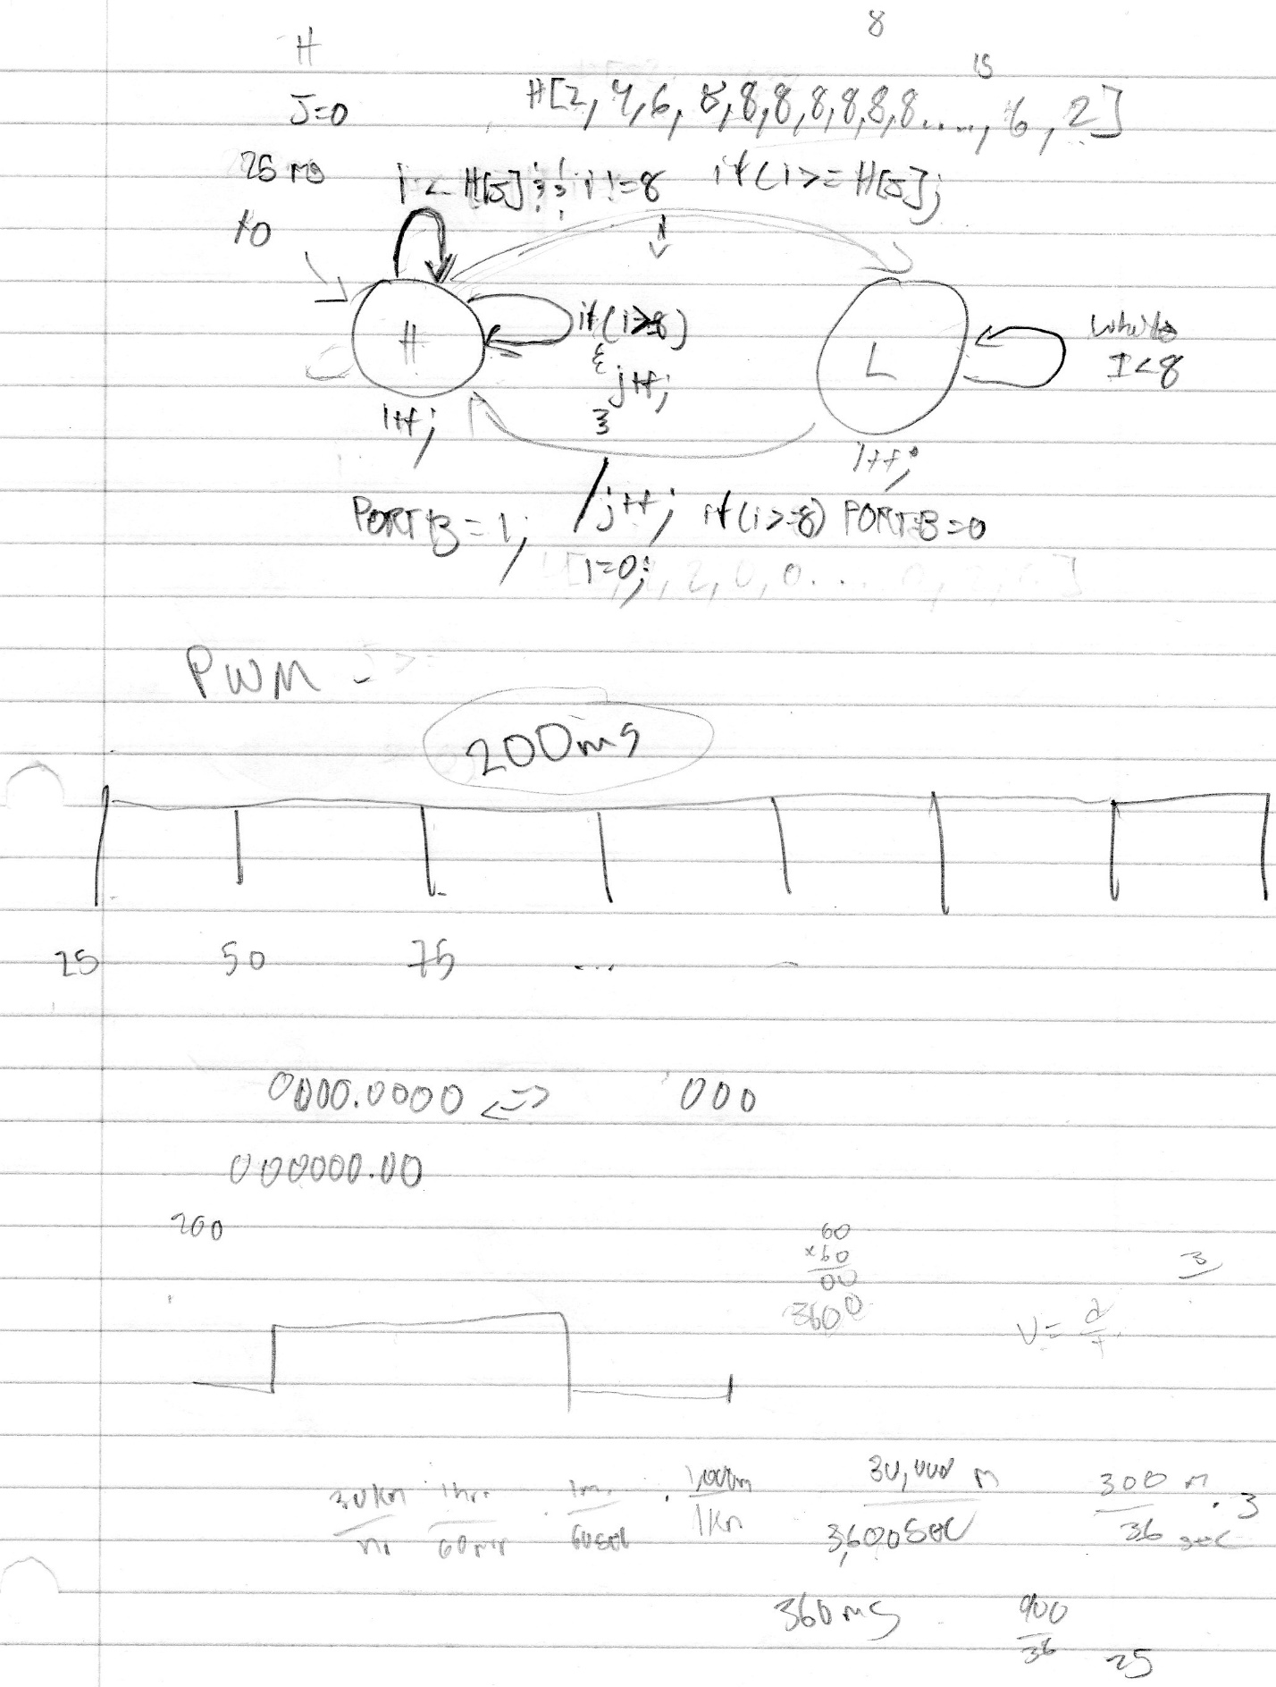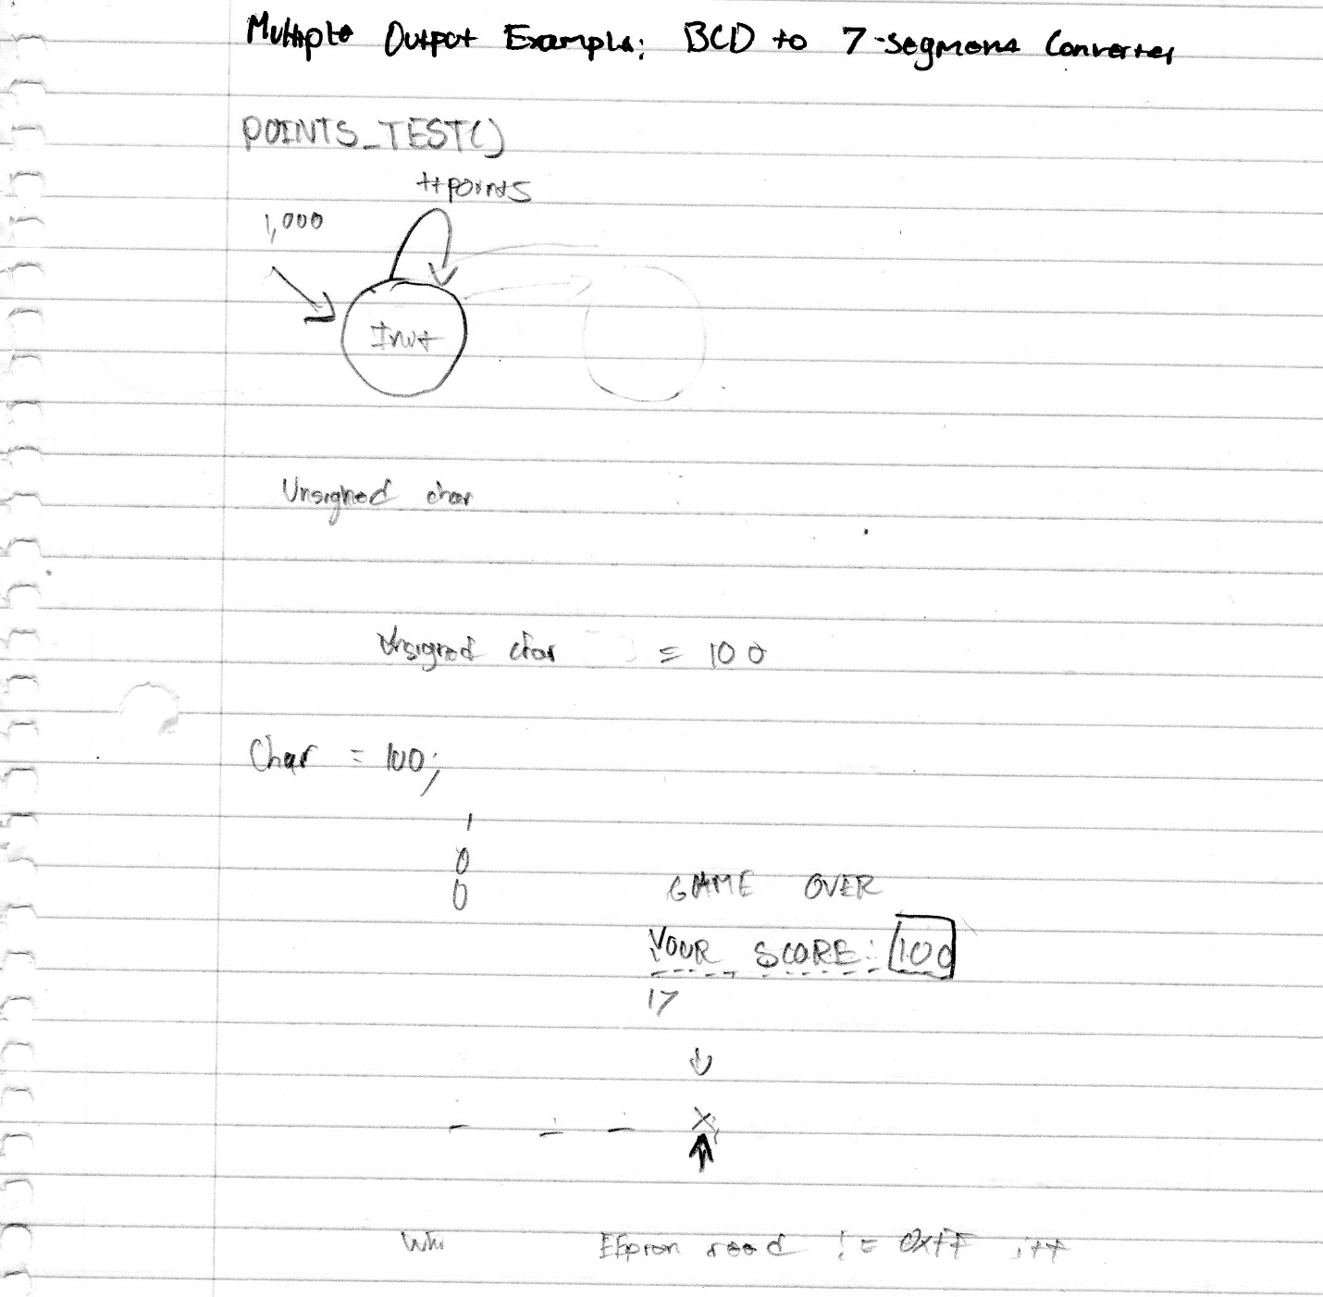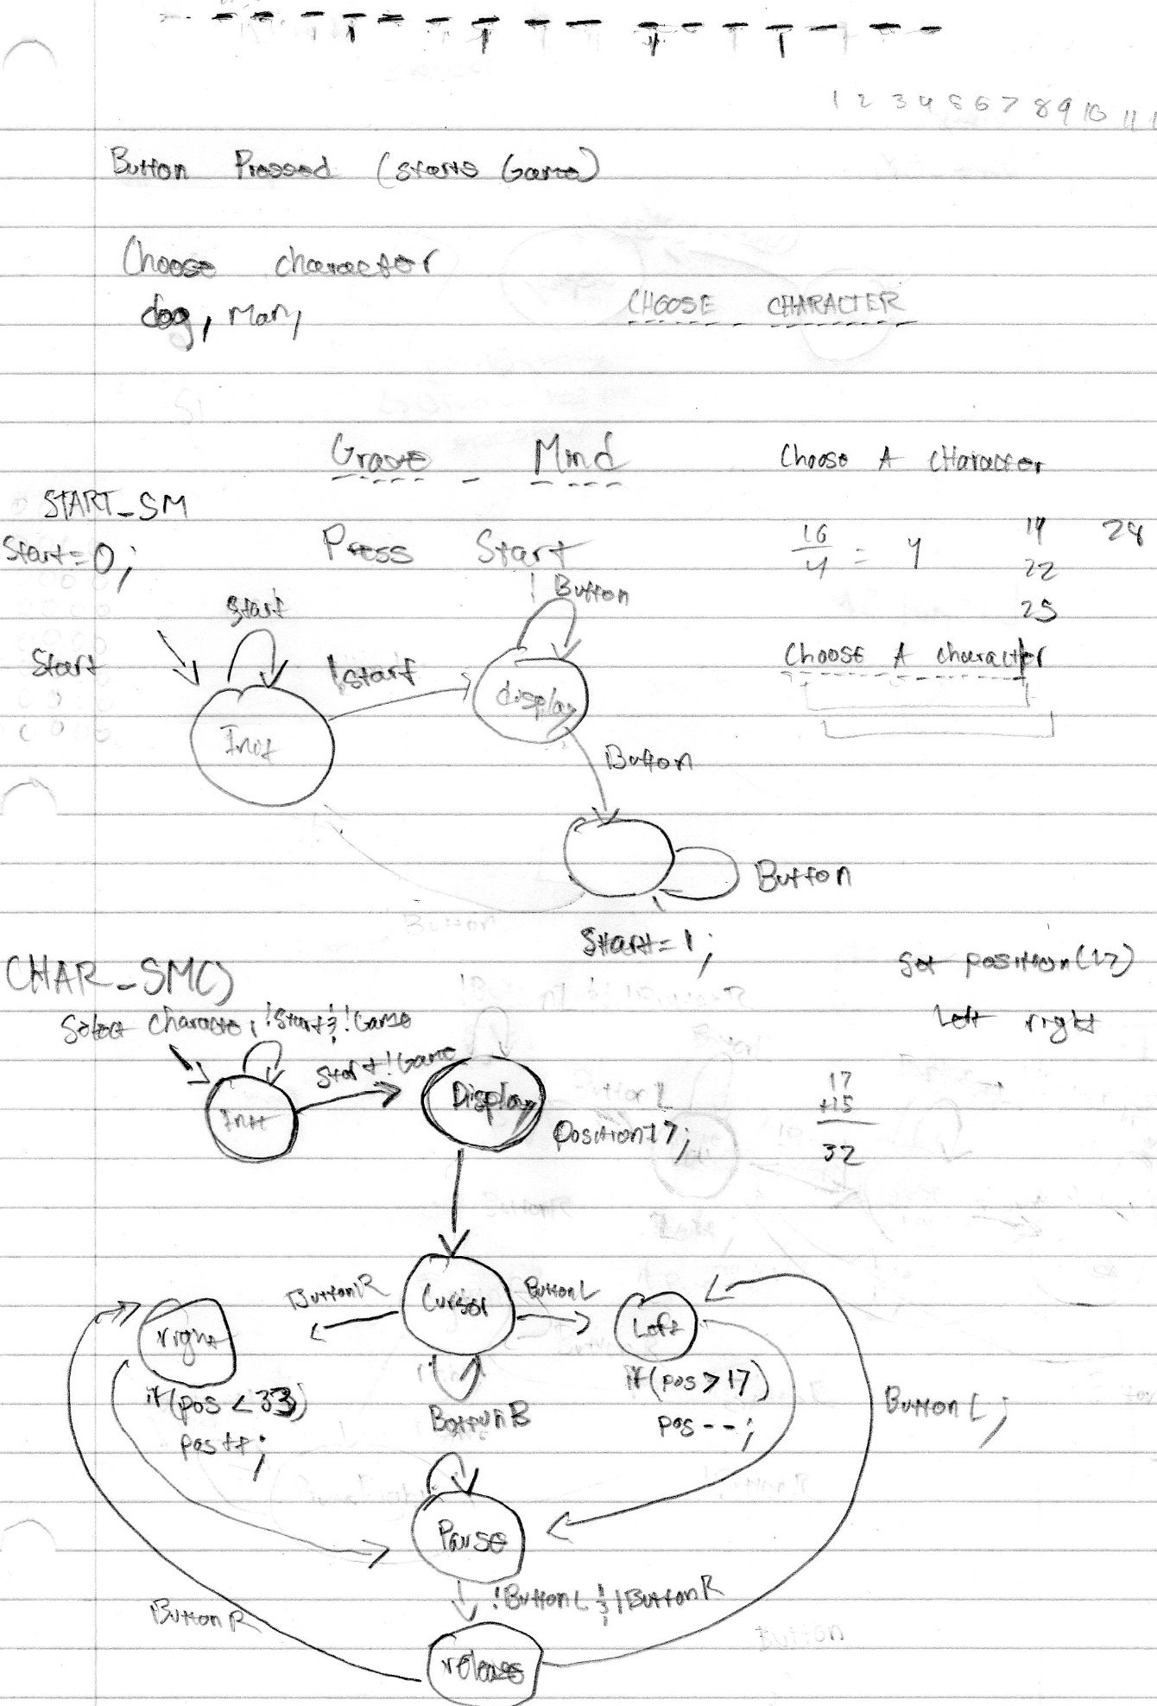

# Complexities

## Completed Complexities:

* Using EEPROM to save the high score (minimum time)
* Creating custom characters on the LCD screen
* Game logic

## Incomplete complexities:

* 2-Player game logic/ setting
* Joystick

# Youtube Link

# <https://www.youtube.com/watch?v=mAgC8azd8uo>

# Known Bugs and Shortcomings

After the first time playing the game, when you click the restart button it allows you to choose a character, but once you start playing the game it seems as if the states run all at once or too fast. It is nearly impossible to not die from this and every reset does the same thing. My guess is that it is a timing issue having to do with some states being the same period. My way of fixing this bug would be to output to 8 LEDs to see if only one value is read from an SM. If not and various LEDs are read then it has to be a timing issue.

It was one of my goals to make a 2-player feature for grave mind, but I was unable to finish it. My goal was to have characters bounce the obstacles at each other and try to get the other person to lose. I would do this by splitting the amount of enemies only viable from one side of the LED and the other two would shoot from the other players side across the screen.

# What did you learn

I learned most of the functions of IO.c to make the function I used to make the custom characters. At one point I had 10 tabs open that described the default commands of the LCD we used in lab LCM-S01602DTR/M. With this research I identified that you could only make 8 custom characters on this LCD type using every 8th location from command (0x40). I looked over io.c to understand the ways those functions were created in order to make my CustomChar function.

Like the LCD I researched the EEPROM using the data sheet provided for the Atmega1284. While using the functions provided, I began researching how to ovewrite/ erase the data written to the EEPROM. While this research hasn’t finished, I plan to find a way.

# International Component

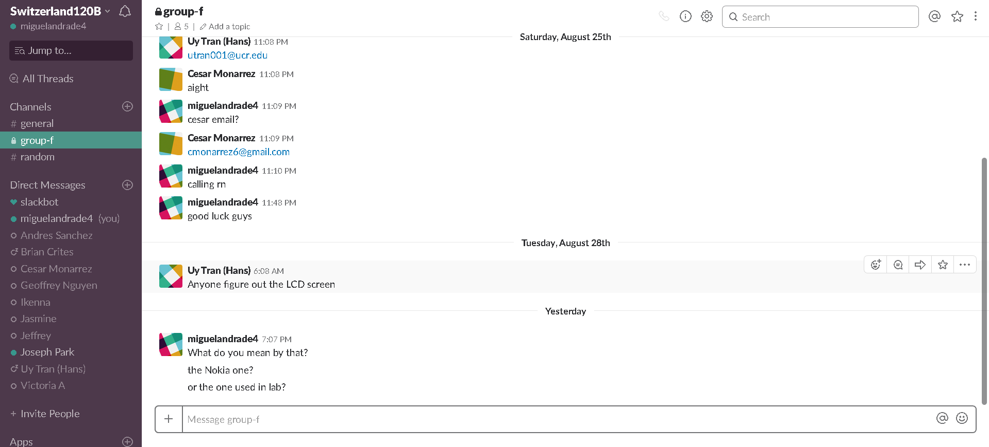

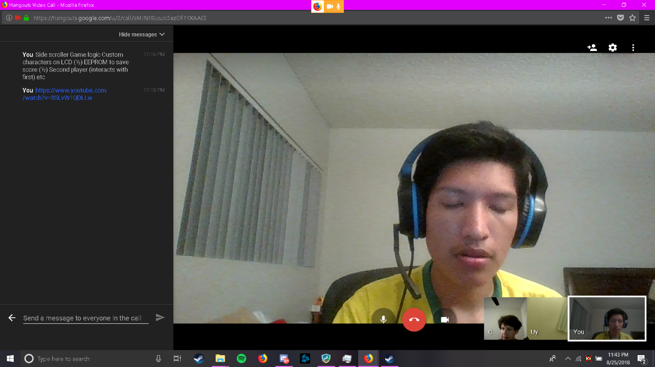

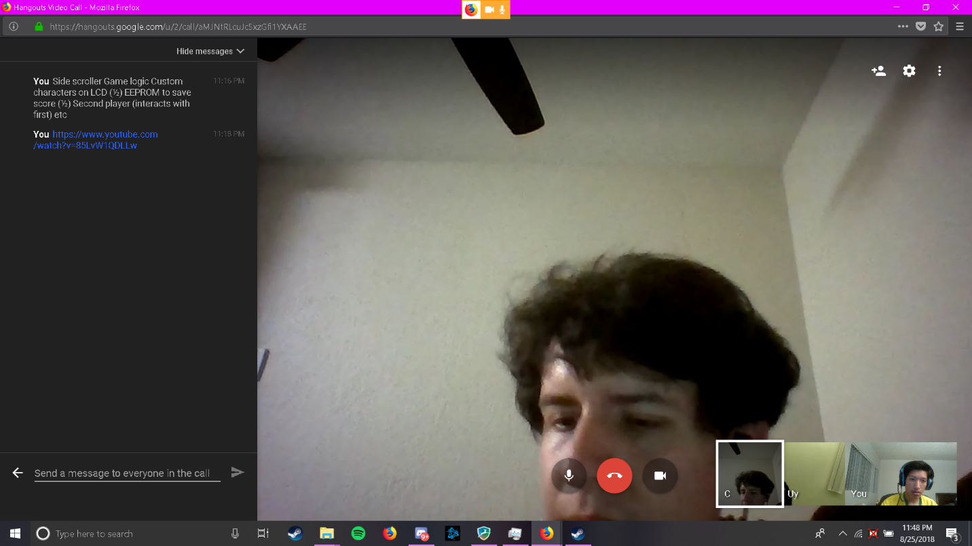

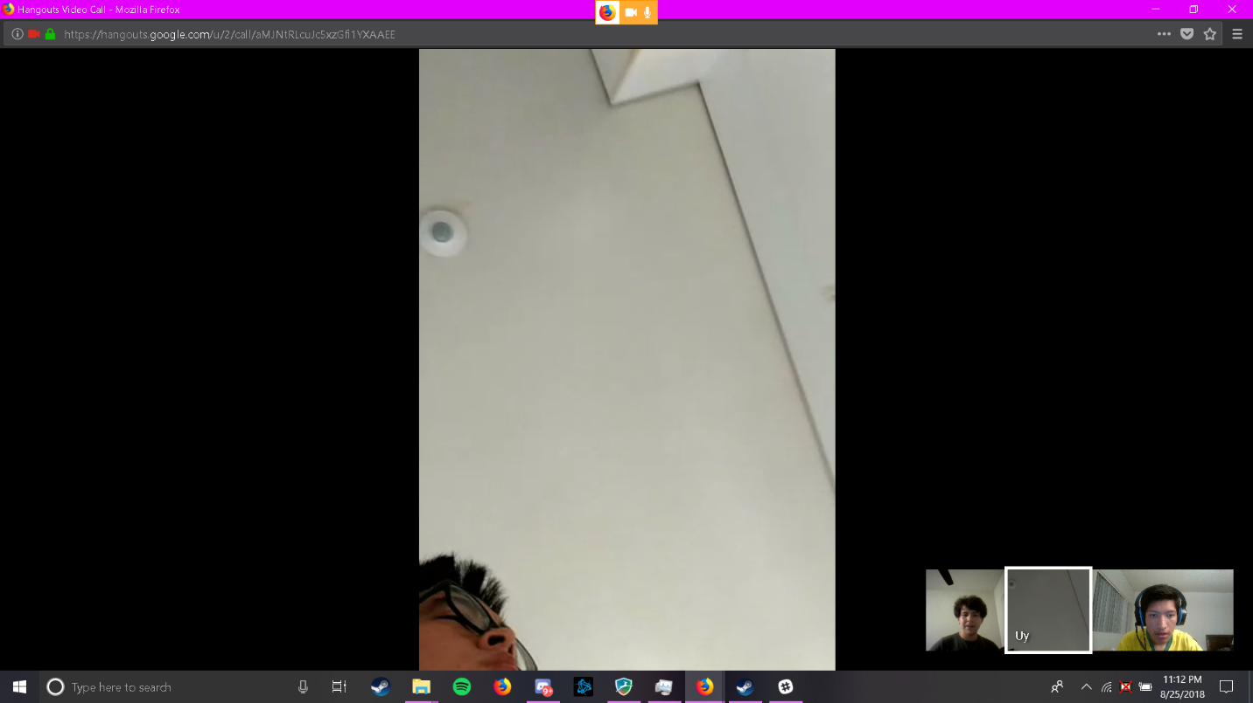

Working alongside someone from Switzerland and from UCR helped me develop thoughts on how I would tackle my project. Conversations were slow to begin but once topics of the project were introduced we all had information or ideas to chip in. We talked about how we would handle the game logic and which complexities we planned to do. To make calls with each other we had to compromise at 11 as that would be 8 am Switzerland time. Our call was full of sharing what we did for summer and how our thoughts on the project were going. I would like to thank Uy Tran and Cesar Monarrez for sharing their ideas.